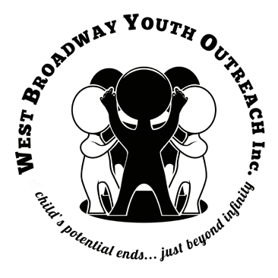Annual Staff Report June 2020 - June 2021

2018 Order of Manitoba Recipient

West Broadway Youth Outreach (WBYO)

WBYO is a life skills program that is camouflaged as a drop-in recreation centre, geared towards youth ages 4 and up in the West Broadway area & beyond. We provide year-round, free after-school & summer programming in a safe, fun & nurturing environment.

WBYO ensures that local children have opportunities to learn and grow in an atmosphere where their basic emotional, social & educational needs are met and supported by positive role models.

Mission: Provide a safe, fun and caring environment where children are provided opportunities to learn and grow. Free structured programming and positive role models instill a sense of accountability, teach life skills, encourage positive behaviour and support children towards achieving their infinite potential.

Vision: Children realizing their potential

Expectations of Each Participant:
- Treat others the way you want to be treated
- Use appropriate language
- Keep your hands and feet to yourself
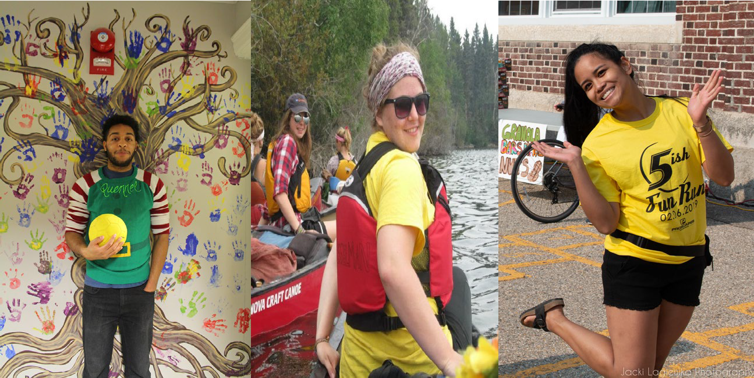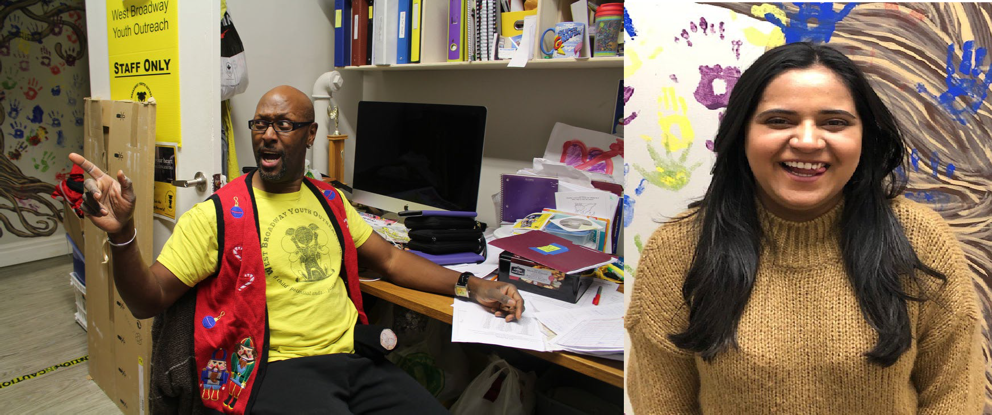
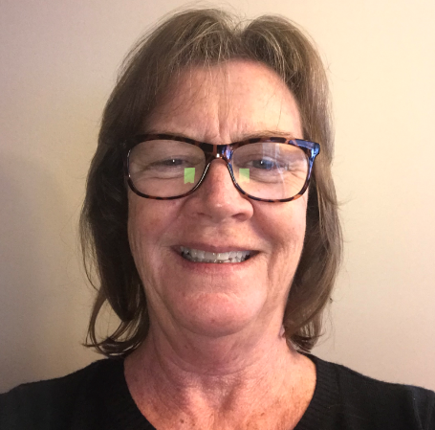

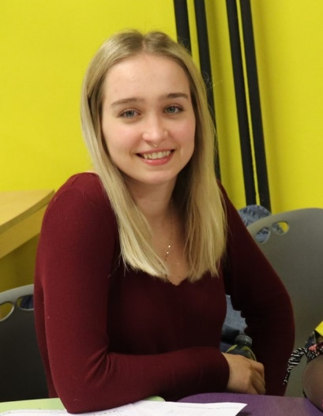
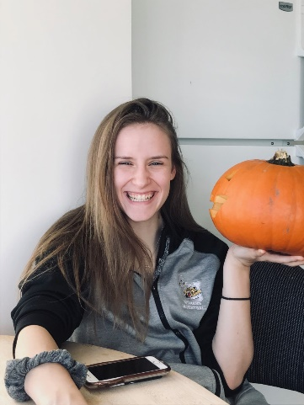

Staff (as of June 2021)
The longevity of staff has provided stability to WBYOs programming for over 30 years. Our team this year is as follows:

Executive Director - Ken Opaleke
(31 years/0 Sick Days)
Director’s Assistant – Alicia Pollett (3months)
Grants Co-ordinator-Loana Valdez (4 years) Bookkeeper – Debra Kusano (4 years)
Homework Club/Matheletes Coordinator - Quennel Miller (6 years)
Dreams Coordinator - Vera Kolesnik
(1.5 years)
Bookjam Coordinator - Jessica Hartog
(2 months)

WBYO Programs
School Session: September - June

MONDAY TO FRIDAY

Bookworms - 3:00 - 4:30 pm (Currently on Zoom)
Bookworms is a literacy program. Kids come by after school and read independently or with staff and volunteers. They may also play with any of the toys, games or computers we have in our space! Every book read is logged and every 10 books read gets them an invite for our monthly Bookworms outing.

Free Play - 3:00 - 6 pm (Postponed)
Kids may go into the supervised play area and have fun with Lego, Barbies, Board games, crafts, and more!

Homework Club - 4:30-6:30 pm (Currently on Zoom)
Homework Club is where kids can bring any school work they have been given (they can and are encouraged to ask their teachers for extra work!), and have a space with snacks, supplies and tutors to help them with their work. Homework kids get spoiled at WBYO with treats, outings and anything else we can think of!
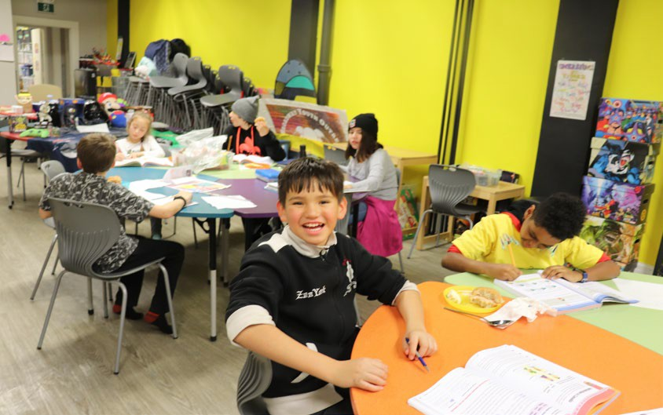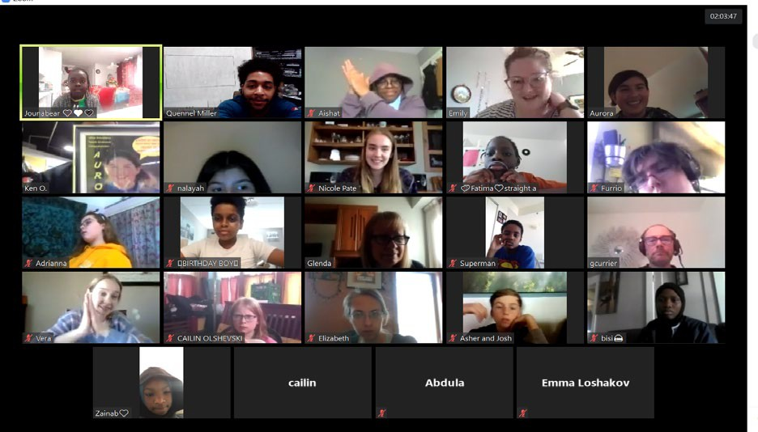

Piano Lessons - 4:00 – 8 pm (Postponed)
Private lessons with our amazing volunteer tutors for 30 minutes each, culminating in an annual Piano Recital in June.

Small Time Fun Pack - Mondays, 6:30 - 7:30 pm (Currently on Zoom)
This program is geared towards the 4 -7 age group held at the Gordon Bell High School gym. Older children are welcome to join, keeping in mind that the day is for the younger group. We play games like Frozen Tag, Ghostbusters, Simon Says, Everybody's It etc. As always, all games played are chosen and voted on by the children!

Board Game Sign Out - 3:00 - 8:30 pm (Postponed)
Kids are encouraged to sign-out any of our collection of board games for a week with a permission form signed by their parent/guardian.

Pen Pal Writing Club – Mondays, 4:00 – 6 pm (Currently on Zoom)
Led by our amazing volunteers who have a passion for literacy, kids are taken to different writing environments where they write letters or postcards to send to family/friends!

Family Swimming - 3:00 - 5:30 pm (Postponed)
Meet at Mulvey School at 3:30 or at 646 Portage by 4:00 sharp to walk over to Sherbrook Pool for swimming! These aren't formal lessons, but are a great time in the pool for kids of all ages.

Mathletes – Thursdays, 6:30 - 8:30 pm (Currently on Zoom)
Mathletes seeks to remove the stigma from math activities and provide an enriched learning environment based on the Manitoba Math Curriculum. Earn Ken Bucks and buy prizes from the WBYO Prize Catalogue created for Mathletes. (Prizes include candy, books, bikes, Ipods etc…)

Comic Club - 3:00 – 5:30 pm (Postponed)
All things comic! Youth are invited to come and read their favorite comic, draw/create their own comic and have facilitated discussions about the best superheroes and authors out there!
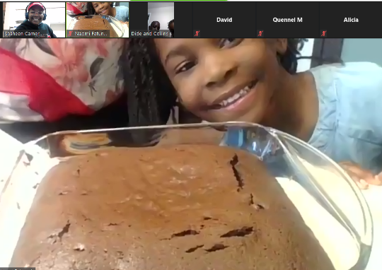
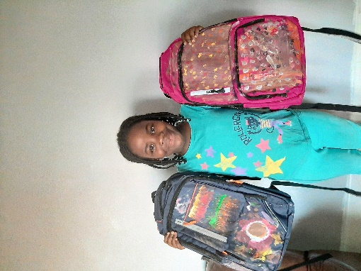
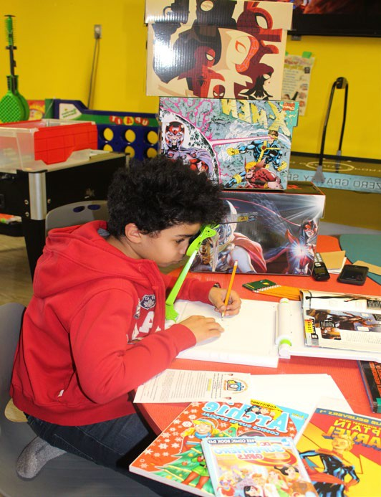

Jam Session - Tuesdays, 4:30 - 5:30 pm (Currently on Zoom)
Kids get the opportunity to learn about different instruments through free play, circle and special music performances.

Kids Laundry Night - 3:00 - 8:30 pm (Postponed)
Kids are encouraged to bring in a small amount of their laundry to be washed during program hours. They are taught how to do their own laundry - laundry soap, dryer sheets and machines are provided free of charge.

Guitar Lessons - 4:00 - 8 pm (postponed)
Volunteer musicians teach interested youth guitar basics with one-on-one lessons. Youth are provided with guitars to practice with and learn how to read music, how to play chords and play their favourite songs from the radio! Guitar students are also showcased in an annual guitar recital in June.

Dreams Program - Tuesdays, 6:30 pm - 8:30 pm (Currently on Zoom)
Dreams is a career mentorship program that provides youth with the opportunity to explore the infinite possibilities their future holds and supplies them with the tools to get there. Tuesday meetings include guest speakers, career info sessions, workshops and large group projects. The Program also provides opportunities for youth to have dinner with a mentor in their Dream career, or shadow a mentor for a day.

After School Program - 3:30 - 4:45 pm (Postponed)
This program is held in the gym at Mulvey school. We play games like change lines, doctor dodgeball, musical hoops and line-tag. All games played are chosen and voted on by the children!

Video Game Party (Homework Club Kids Only!) - 3:00 - 6 pm (Postponed)
This program is held at our centre and is a chance for homework kids (only) to unwind after school by challenging one of our awesome volunteers to any number of non-violent video and arcade games, playing mini-basketball or tetherball, and enjoying some of our most awesome toys – all prior to hitting the homework books.

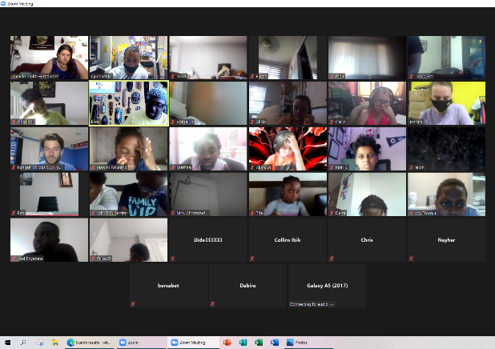
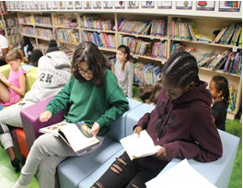

Yum-Yum Club - Wednesdays, 6:30 - 8:30 pm (currently on Zoom)
Kids are encouraged to join our amazing volunteer nutrition students as they instruct and prepare delicious and healthy meals for all the kids at our centre!

Crafts, Nails, Lego Mania - 3:00 - 5 pm (Postponed)
Kids can come for "give and get" manicures, crafts and games! We also pull out a giant box of 45,000 Lego pieces to play with.

Family Yoga – Tuesdays and Thursdays 5:30 – 6:30 pm (Currently on Zoom)
Certified yoga teacher volunteers guide the group through a relaxing, yet fun- filled session in the Mulvey School gym. Yoga mats are provided and no experience is necessary! This program encourages parents, grandparents, aunts, uncles, cousins – everyone – to join in on the fun!

Team Sports Night - Thursdays, 4:30 - 5:30pm (Currently on Zoom)
This program is geared towards the 8-12-year-old age group. Younger children are welcome to join in and often do. We use either the field or the gym at Mulvey School. On these nights, we play games like basketball, soccer, soccer-baseball, volleyball, baseball and floor hockey. As always, all games played are chosen and voted on by the children!

Girls' World - Fridays 6:30 - 8:30 pm (Currently on Zoom)
Girls in grades 5-10 are welcome to join our Girls' World at our centre. Programming is self-directed by the girls and often offers exciting and empowering outings. Projects

Book Jam - 6:30 - 8:30 pm (Currently on Zoom)
Exciting literacy program for youth looking to increase their reading skills through games, crafts, cooking etc. in a fun, safe environment at our centre. Parents (as always) are encouraged to join in!

Boys’ World - 6:30 - 8:30 pm (Currently on Zoom)
Boys’ World invites young men aged 10-15 to participate in unique activities.
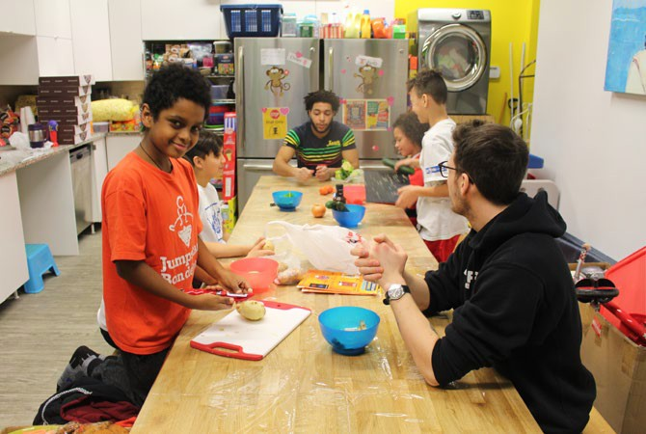

Mystery Book Search (Postponed)
Mystery Book Search is an incentive program focused on reading. Two books are chosen (One in Easy-Readers and one in Novels). If a youth reads a chosen book to a volunteer, or submits a book report, the youth wins great prizes. Prizes are added each month the chosen book is not read. The prize is currently at over
$2800.00!

WBYO Special Events & Highlights

June 2020
  - 95% programming moved to zoom
  - 9th annual 5ish Fun Run- turned into the 9.5ish via zoom
  - 1st Annual Virtual Skip-A-Thon
  - Young Eagles Take Flight program (postponed)
  - Annual Piano Recital at Lion’s Place (postponed)
  - Top 10 Homework Club Kids and Top Reader acknowledged and usually taken to annual Red River Ex outing;(postponed)
  - Celebrity Homework Club Tutors/ volunteer weekly
  - Care packs, craft and yum yum club kits delivered
  - One to one Basketball, soccer, badminton, and boxing training
  - Yoga kits dropped off

July 2020
  - Straight A Effort Students given extra 1 to 1 attention to ease the pain of
  - Summer events (see calendar) August 2020
  - Summer events
  - Rotary Graduation
  - Fantastic 5 outing to Ontario September 2020
  - Back to School Dance
  - Dreams Film festival October 2020
  - Halloween Trick or Treat Outreach
November 2020
    - Volunteer Appreciation Night December 2020
  - Annual Holiday Party
  - Straight A effort holiday party
  - New Years’ Dance
  - Extra Special Homework Club outings around our city (see calendar)
January 2021
  - Extra Special Homework Club outings around our city (see calendar)
  - Annual Flight Lessons February 2021
  - Annual Valentines Dance
  - Festival de Voyageur

March 2021
  - Basketball and Floor Hockey tournament (Postponed)
  - Lawyers for Literacy (Postponed) April 2020
  - Annual Volunteer Appreciation Wine and Cheese Night (hosted by staff) (Postponed for now)
  - Spring break Outings

April 2021

May 2021
  - Youth in Philanthropy Celebration (Postponed)
  - Skip-A-thon and 9.5ish Warm up
  - Sunday Ice Cream Walks every week
  - Celebrity Homework Club Tutors volunteer weekly (via zoom)
  - Care packs, craft and yum yum club kits delivered

June 2021
  - 2nd Annual 9.5ish Virtual Exercise Extravaganza via zoom
  - 2nd Annual Virtual Skip-A-Thon
  - Top 10 Homework Club Kids and Top Reader acknowledged and usually taken to annual Red River Ex outing;(postponed)
  - Celebrity Homework Club Tutors/ volunteer weekly
  - Care packs, craft and yum yum club kits delivered
  - One to one Basketball, soccer, badminton, and boxing training
  - Yoga kits dropped off

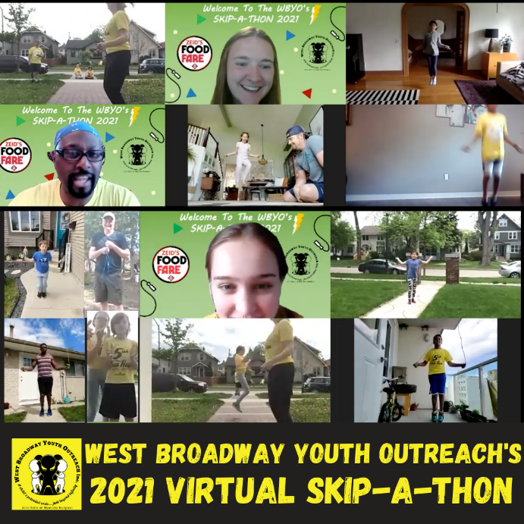

Staff Goals for 2020-2021 were:
- Have 500 people register for the 10th annual 5ish Fun Run. And Skip-A- Thon
- Continue to remind our kids that their potential ends just beyond infinity.
- Diversify and secure funding for ongoing operations and staffing.
- Make a sponsor opportunities list to encourage sponsorship of various activities (i.e. The Red River Ex, Visiting the Zoo, etc…) .
- Expansion of space for programming and adding staffing.
- Look into a new annual fundraiser involving the community (i.e. Ride for Kids and food for thought.

Staff Goals for 2021-2022:
- Have 500 people register for the 10th annual 5ish Fun Run. And Skip-A- Thon
- Continue to remind our kids that their potential ends just beyond infinity.
- Diversify and secure funding for ongoing operations and staffing.
- Make a sponsor opportunities list to encourage sponsorship of various activities (i.e. The Red River Ex, Visiting the Zoo, etc…) .
- Expansion of space for programming and adding staffing.
- Look into a new annual fundraiser involving the community (i.e. Ride for Kids and food for thought.

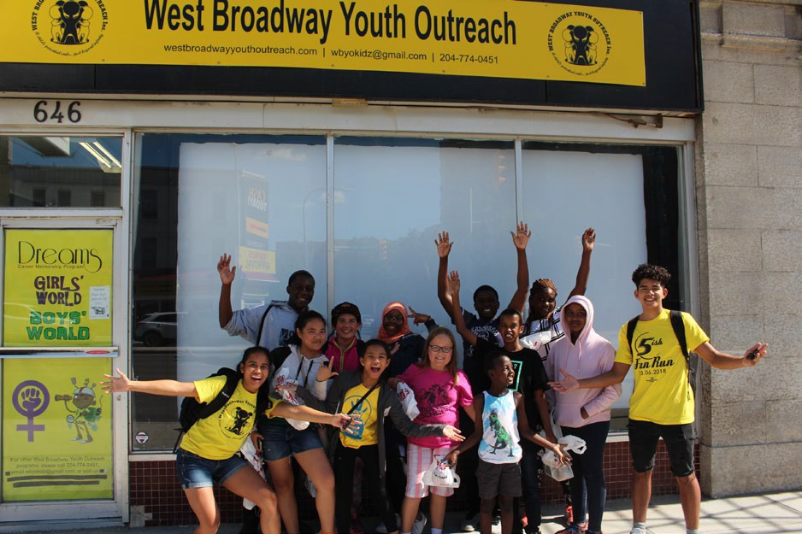

Special thanks to our friends and sponsors (in alphabetical order):

103.1 Virgin Radio Assiniboine Credit Union Balmoral Hall School Carolyn Sifton Foundation Christmas Cheer Board Chew
City of Winnipeg Councillor Sherri Rollins Dignity Memorial
EAA Aviation Foundation’s Young Eagles Program
Festival du Voyageur Graham C. Lount Foundation Home Depot
Johnston Group
Kiwanis Club of Winnipeg Law Society of Manitoba
Massage Therapy College of Manitoba McLaughlin Capital Management Mercedez Benz
Mulvey School Staff Nike
Neptune Properties Inc. Polet Family
Prairie 360 Proscapes RBC
Richardson Foundation Running Room
Service Canada
Shaarey Zedek Congregation Sherbrook Pool
Shoppers Love.You St. John’s Ambulance Sussex Realty
Thomas Sill Foundation Towne 8 Cinema United Way of Winnipeg Urban Green Team West Broadway Biz
West Broadway Community Organization
Winnipeg Foundation & Youth in Philanthropy
Winnipeg Goldeyes Winnipeg Harvest Youth Agencies Alliance Zeid’s Food Fare
and Anonymous Donors!

***And last but certainly not least, a HUGE THANK YOU to the children and families of West Broadway for allowing us the privilege of being a part of their lives***

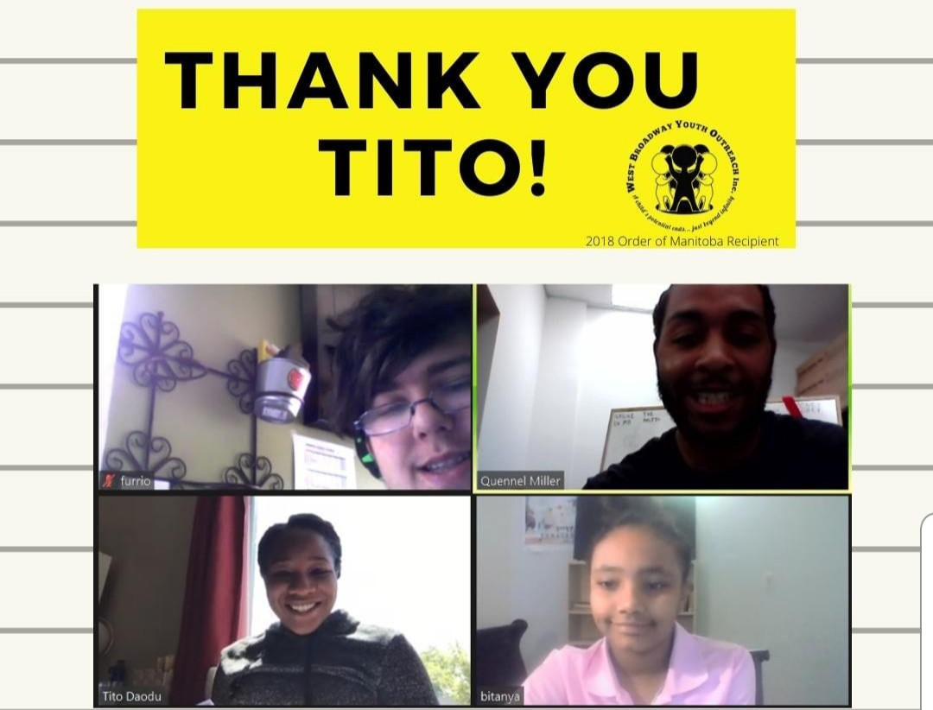

Ex-Homework Club SUPERSTAR!!

WBYO’s Homework Club and Canada’s first black female surgeon returns as always to lend a helping hand in Homework Club.

